POLYSNAKE
REPORTS

Soufiani
Younoussse
2022/2023
Session1
14/10

I have started to schematizes some simple situation to visualize how the program will work.
Situation 1(left turn):
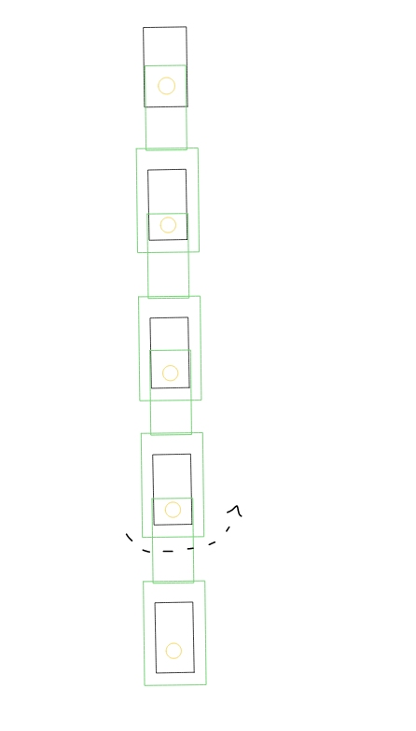
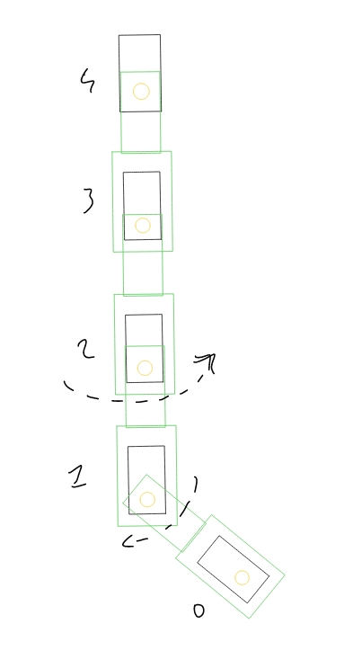
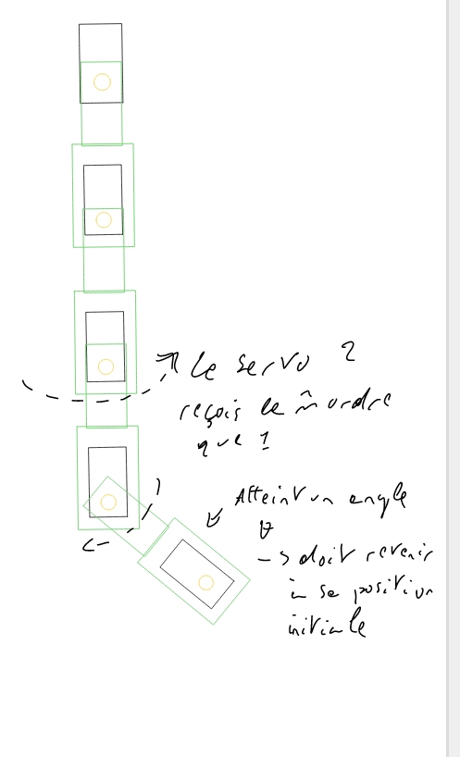
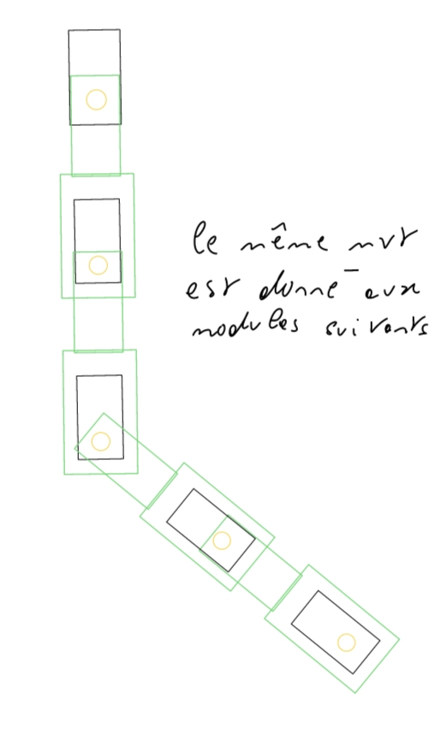

study of the servomotor and the Arduino library needed to use it.
I start by moving one servomotors then two of them.
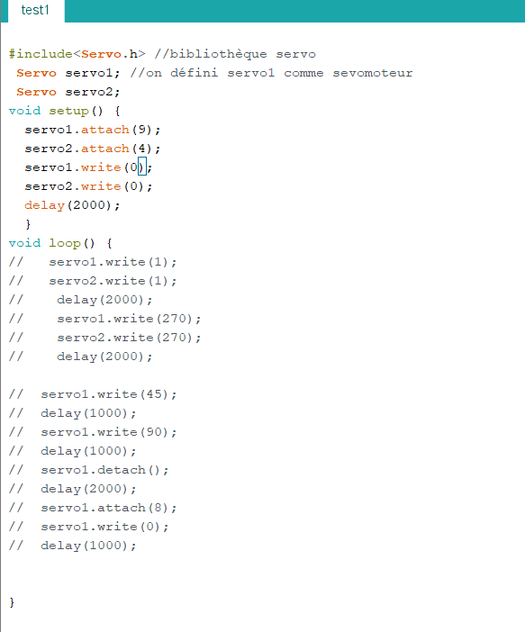
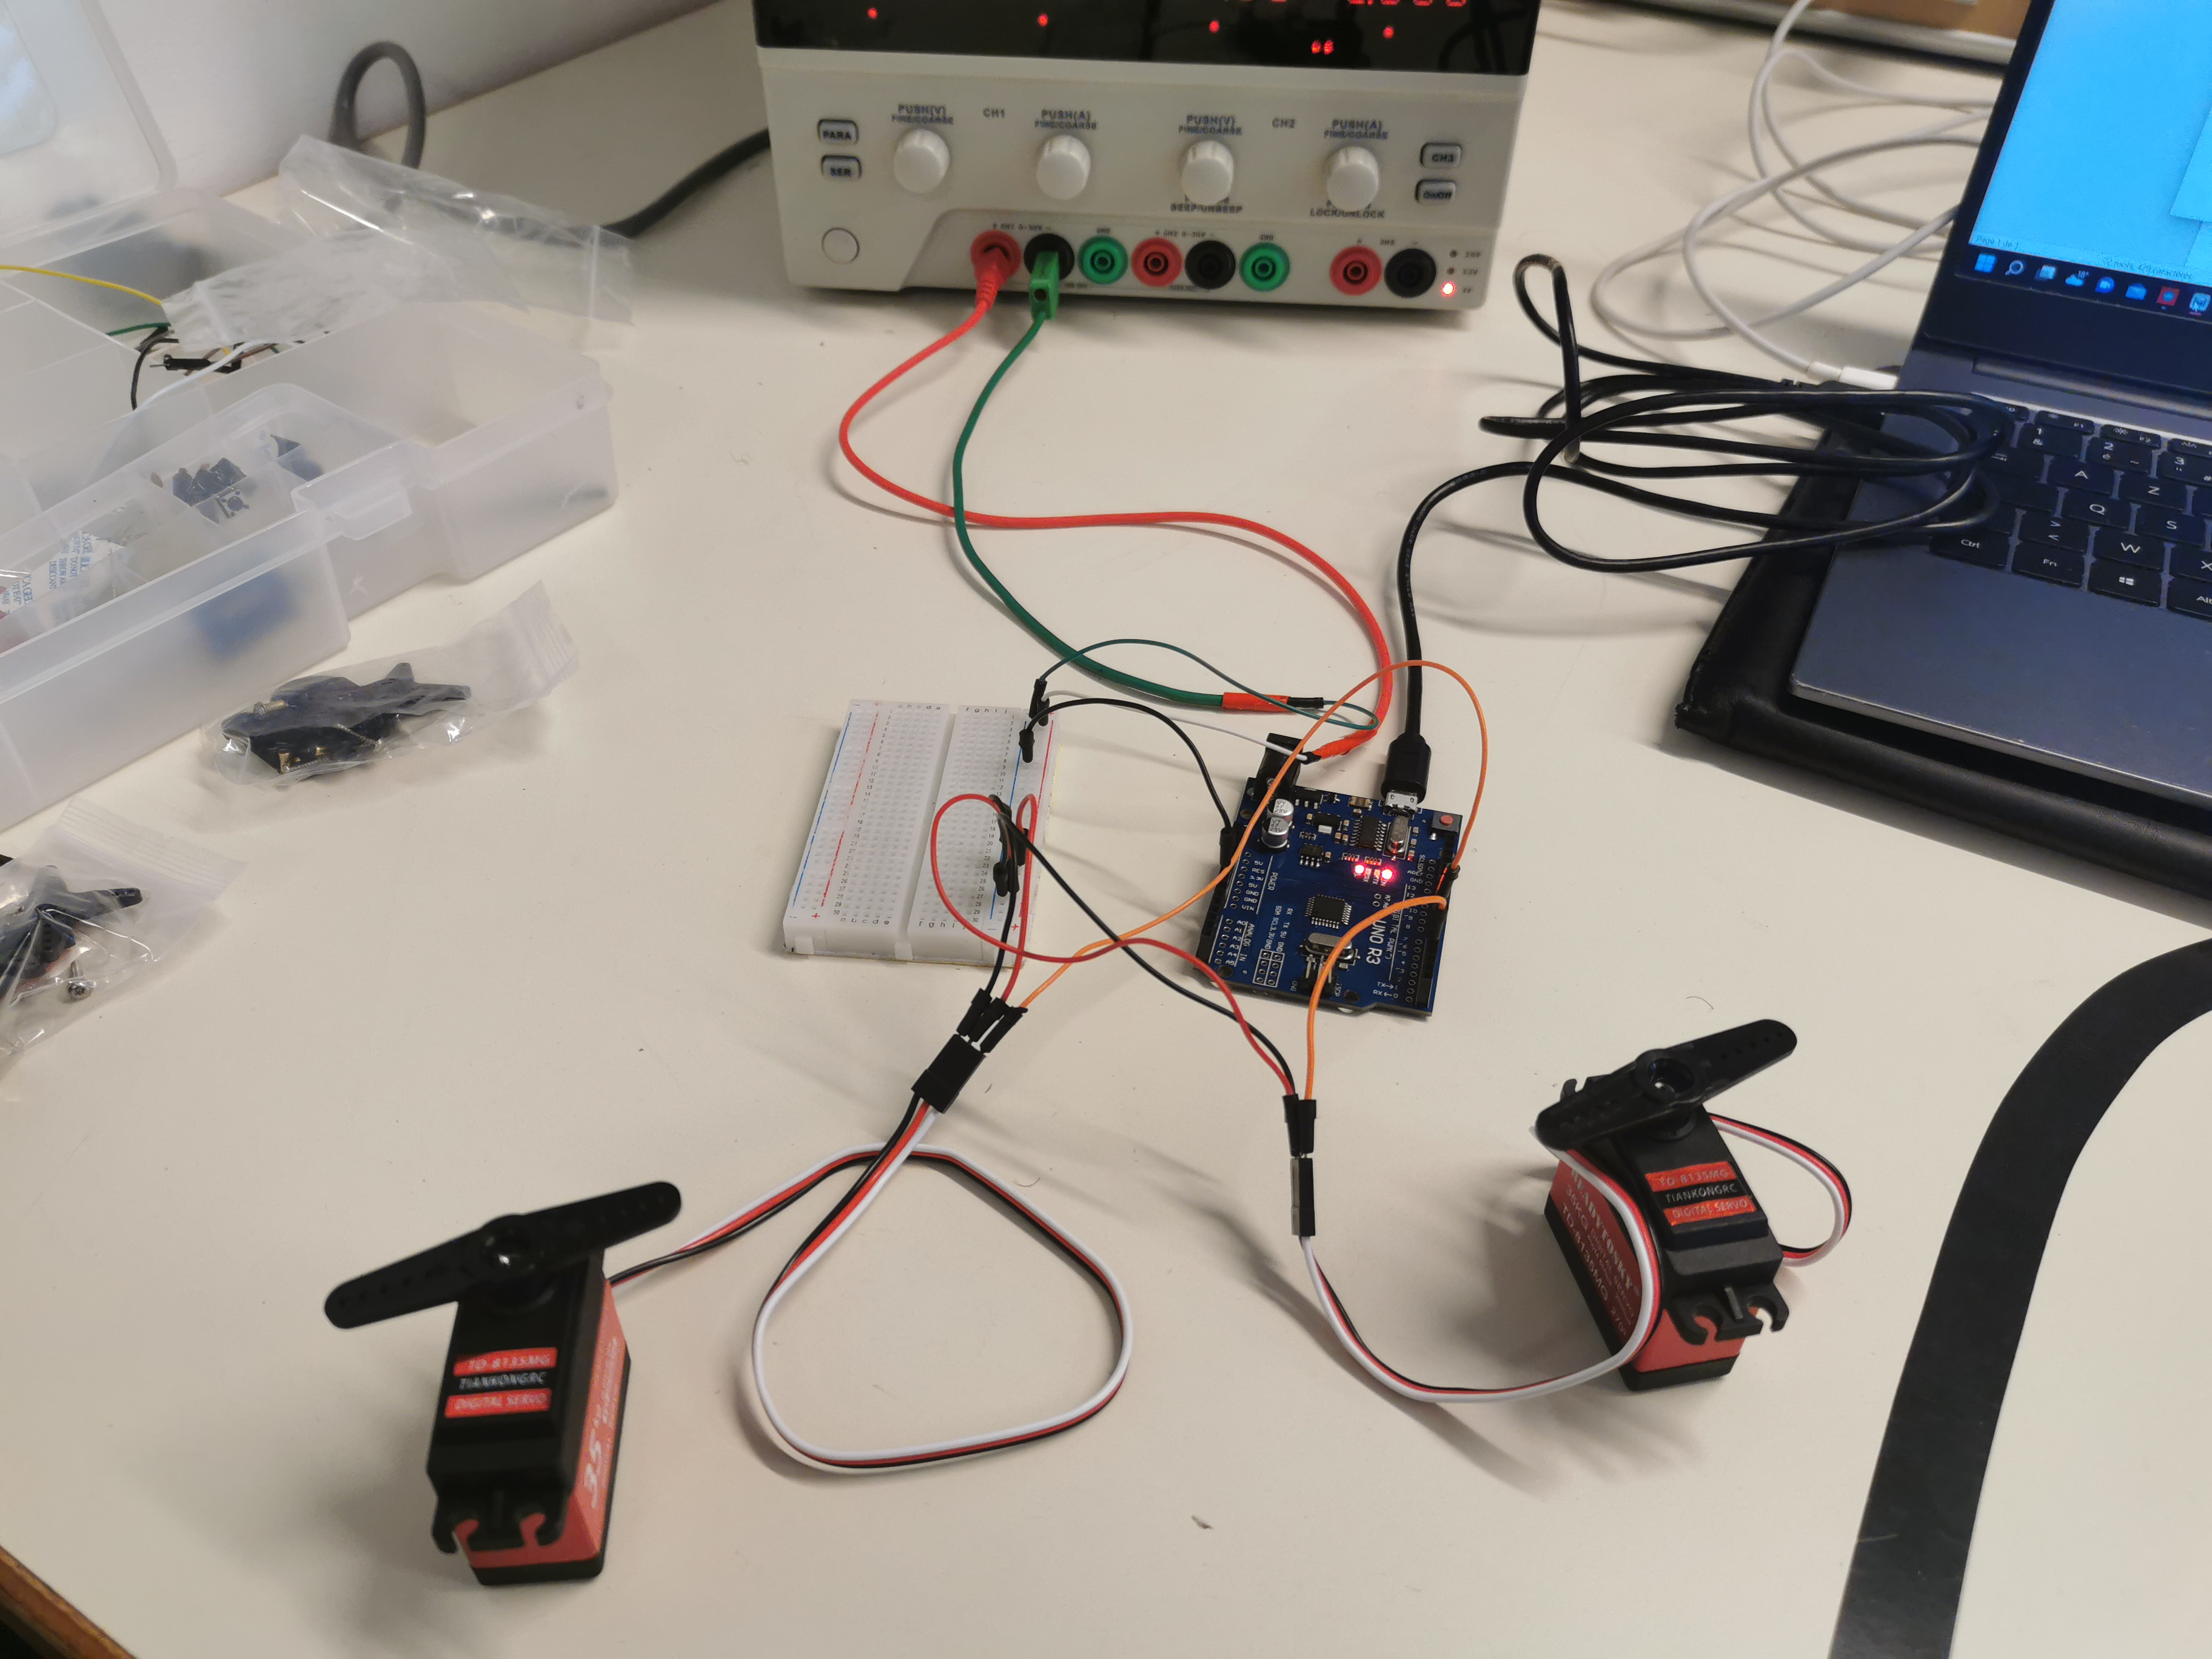
There is the program used

There are troubles with the servomotors:
- some unwanted movement
- trouble to reach the ask angle
- issues to synchronize the servomotors together
Those issues may come from the fact that those servomotors unlike the usual I use goes to 270 degrees.
I will have to gather more data about them.

